VPC Challenge

The challenge is to Set up Transit Gateway and VPC Endpoints for a Multi-VPC Architecture

Scenario:
A large organization is migrating its on-premises infrastructure to the AWS cloud.
The organization's architecture involves multiple VPCs for different departments and
applications, each requiring secure communication with centralized services and external
resources.
Process:
Create 3 new VPC’s
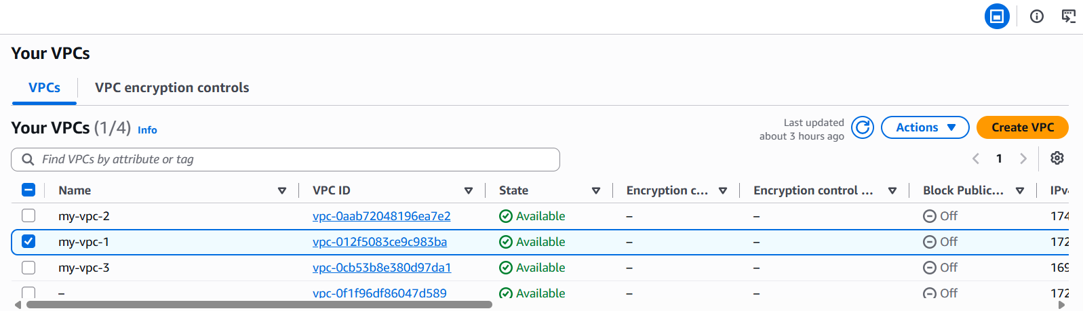
Create 3 new public subnets and configure it in route table
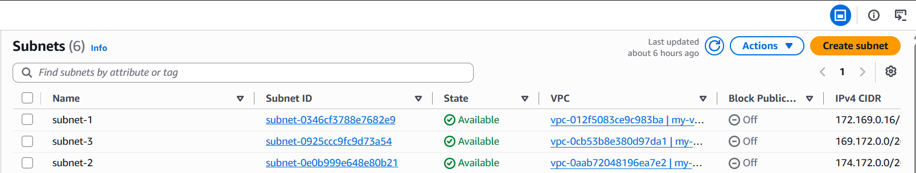
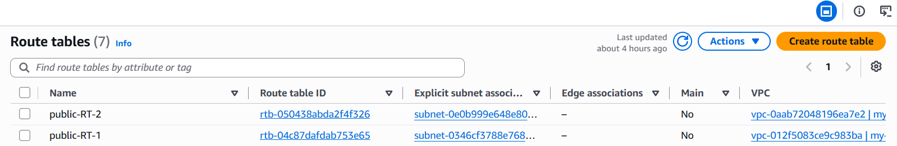
Create a transit gateway
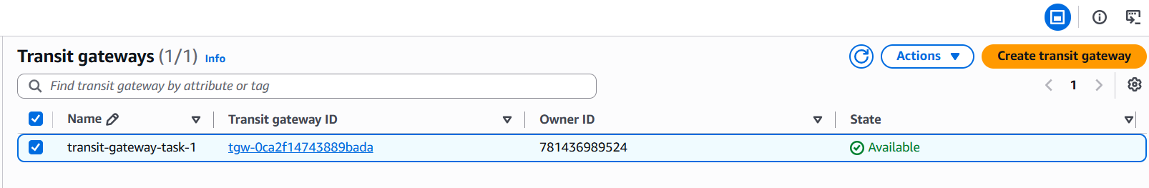
And create attachments according to the number of VPC’s
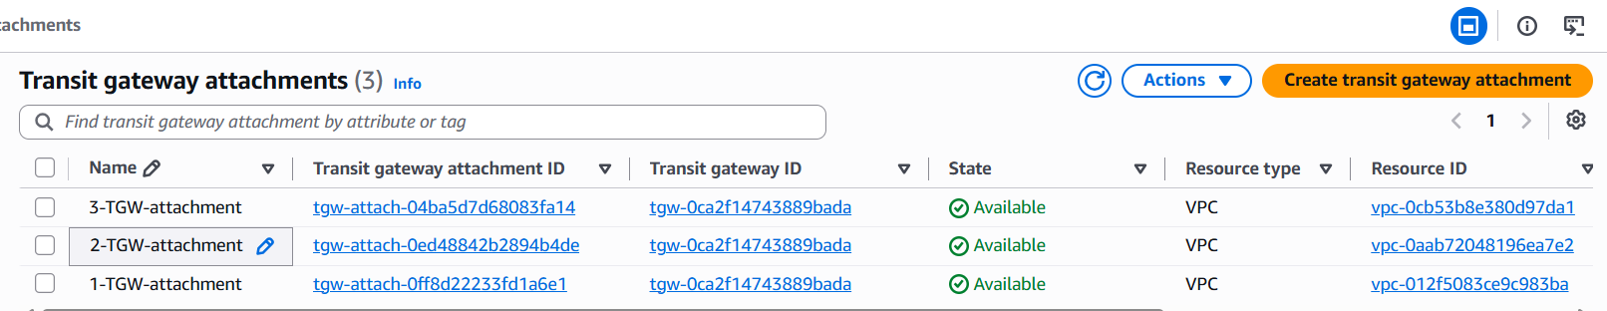
Configure the route tables with CIDR of other VPC’s which we are attaching
